Cosentino unveils Capsule Collection, the first-of-its kind Dekton furniture line

5 top regional design houses break boundaries to create furniture and home accessories collection with Cosentino’s 4mm Dekton Slim

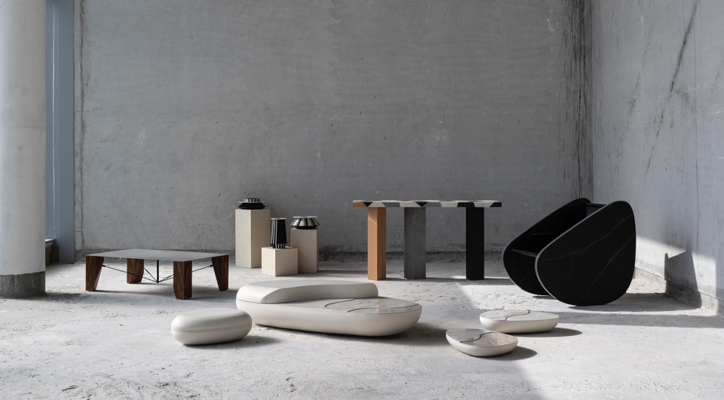
Dubai, 1 August 2021 – Architectural surfaces leader Cosentino today unveiled its much-awaited Capsule Collection of furniture and home accessories created in collaboration with celebrated designers Nada Debs, Mustafa Khamash, Fadi Sarieddine, Aljoud Lootah and the duo Dana Al Matrook and Newsha Dastaviz from The Line Concept.
Unified under the theme “Breaking Boundaries”, the Cosentino Capsule Collection is an ode to Dekton Slim, the 4mm ultracompact material format born out of Cosentino’s commitment to innovation, sustainability and pushing the boundaries of surface design. Using Dekton Slim both as a functional and decorative feature, the collaborators have pushed the boundaries of the material to its full potential to create 5 individual works of art in their signature design styles.
The eclectic collection comprises of a rocking chair, a console, a coffee table, a range of low side tables and a series of vases, created within a period of 4-months by the renowned collaborators.
Commenting on the occasion, Miriam Llano, Marketing Manager – Cosentino Middle East said, “We are pleased to unveil the first ever Dekton Slim Capsule Collection worldwide. This project, which we kickstarted in March 2021, is a true labour of love. The unique creations, proudly Made in the UAE, is an ode to the spirit of collaboration, sustainability and breaking boundaries in every sense – material, design, process and production.”
Dubai-based interior fit-out contractor Cherwell played an integral role as the Production Partner on this project. Talking about how their production design team surmounted challenges, CEO Tom Brooks said, “4mm material obviously has its advantages but it needs be to handled differently. Using our advanced 3D software and a 5-axis waterjet we were able to tackle some of the more intricate elements of the designers’ work, in some instances working with very small and complex shapes cut multi-directionally. This was the designers pushing us to the limit! But that we were able to create these challenging bespoke designs is a testament to the material. It has given us the confidence that there is nothing we cannot achieve through collective effort.”
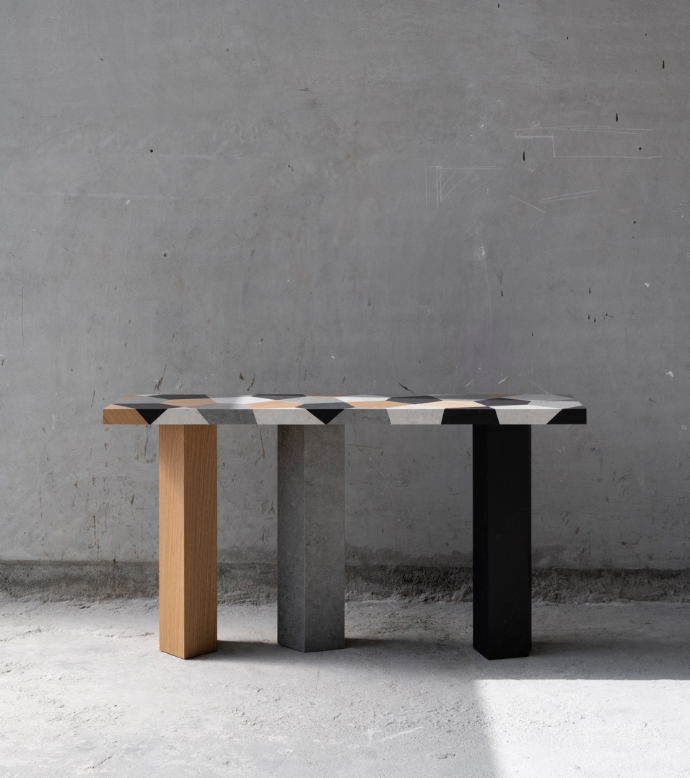
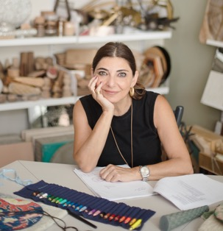
CARAPACE CONSOLE by Nada Debs for Cosentino
In line with the Nada Debs philosophy of creating unexpected material combinations, this console creates a synergy of opposing elements through a playful geometric composition of both natural and industrial elements that fit seamlessly together through the craft of marquetry using the house’s signature Carapace pattern.

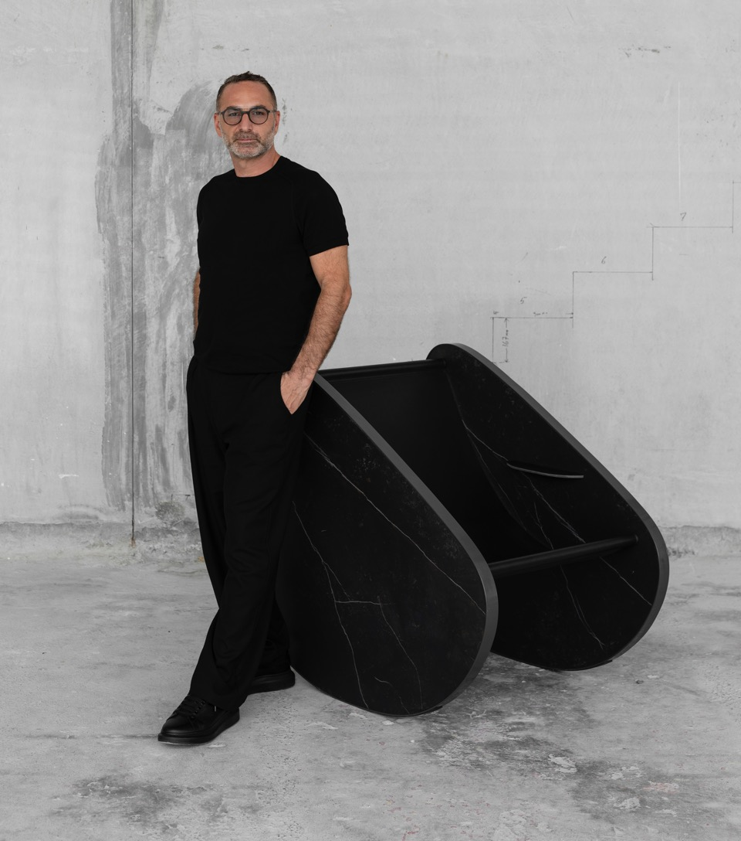
ROCCO by Mustafa Khamash for Cosentino
Was the first chair a stone? Rocco, designed by Mustafa Khamash, looks to the origin of commodities, the starting point being that if a stone was the first object from nature claimed to be a seating device, then it is likely that it also marked the beginnings of furniture making, design, craftsmanship, chairs, thrones, hammocks and other objects. This act of appropriating our natural elements and redefining their use towards providing for our needs sowed the seeds of our never-ending cultural development.
Drawing references from known rocking chairs in the design world, Rocco is a playful creation executed in the raw quality of Dekton Slim, without any unnecessary additions, finishes or embellishments. It represents Khamash’s view on how we treat materials either for dressing ourselves, dressing our domestic context and the aesthetic quest for the abstraction of art.
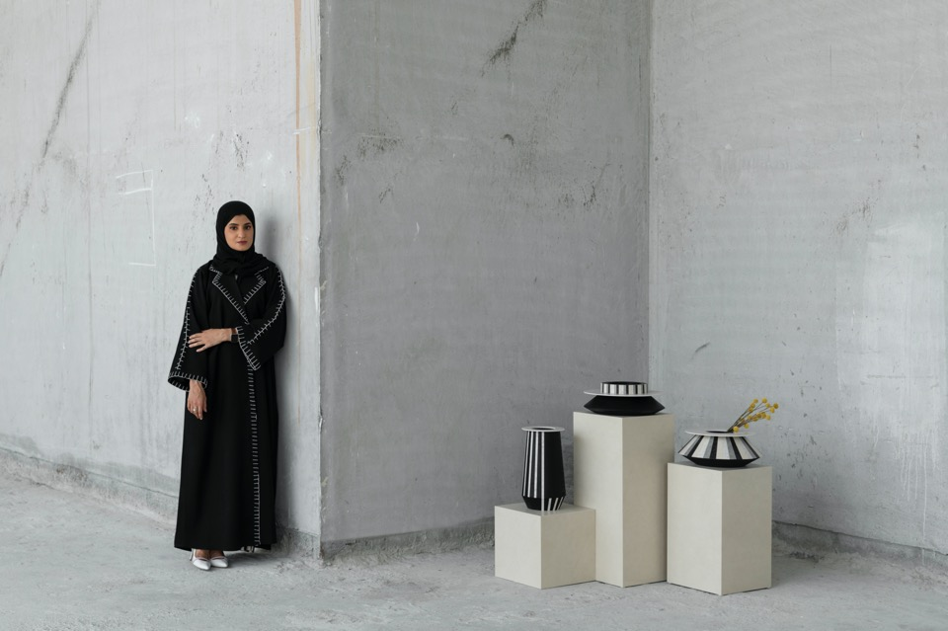
TALYD by Aljoud Lootah for Cosentino
Drawing inspiration from large traditional metal pots used for cooking over open fires, Talyd is a collection of vases that pay homage to the UAE’s rich culinary culture and the everyday tools and objects intertwined with the livelihood of the Emiratis from an era gone by.
Meaning legacy in Arabic, Talyd is a modern interpretation of historical findings. While the shapes and proportions of the vases are influenced by the original artefacts, they are repurposed as functional objects of curiosity using a minimalist design approach.

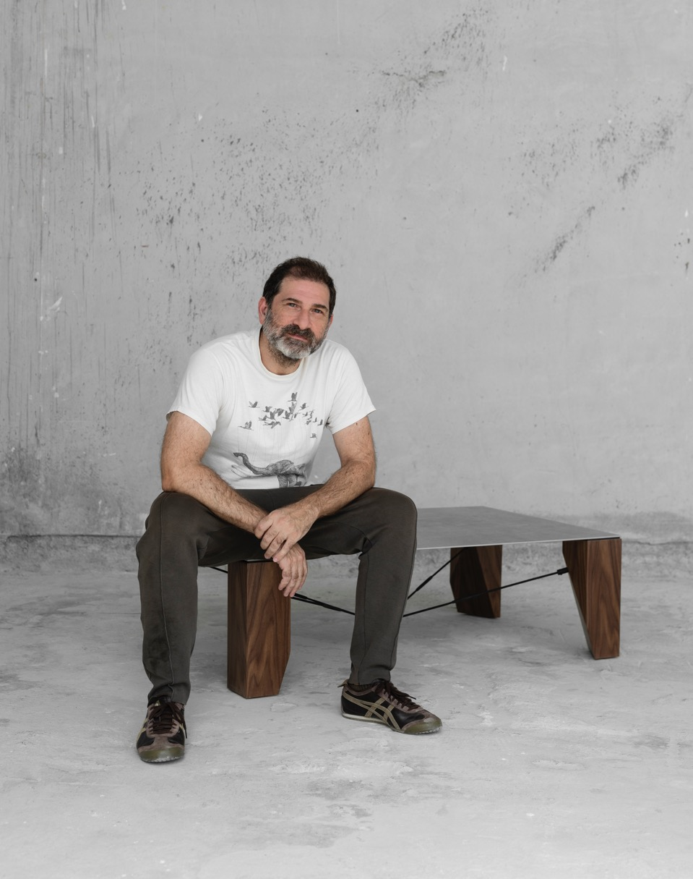
PAPER COFFEE TABLE by Fadi Sarieddine for Cosentino
Paper Coffee Table is a creation that celebrates the thinness of Dekton Slim.
With its fine 4mm edge exposed, the material appears to hover as a table top, an engineering feat achieved through a system of bulky solid walnut legs held in place with gunmetal tension rods. The slimness of the slab is further visually enhanced by the deliberate bulkiness of the legs. Paper Coffee Table derives its elegance from this contrast as well as the geometry generated from the structural factors of tension and compression. The striking material combinations also play a crucial role in complementing the table's morphology.

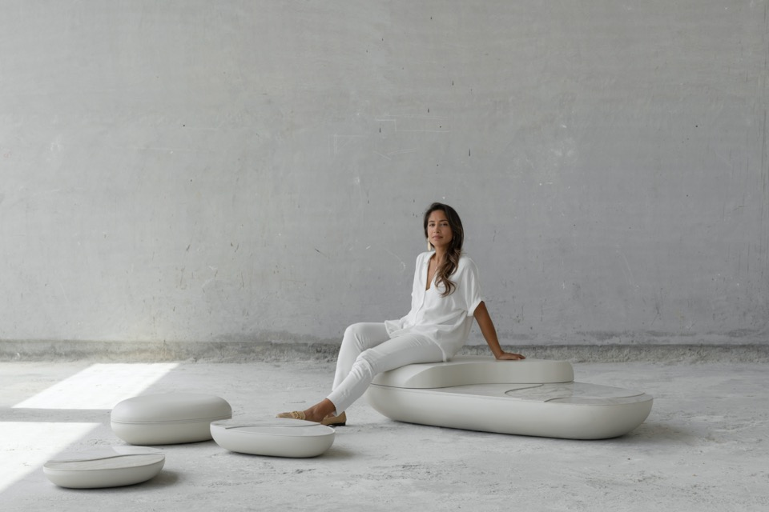
TEKTONIA TABLES by The Line Concept for Cosentino
Soft and organic lines challenge the perception of stone as a hard, cold and sharp material in Tektonia Tables, created by The Line Concept as a tribute to the true origins of the earth. The design integrates organic flowing shapes, symbolizing nature and Earth’s patterns. Parts of the tables are sliced off to expose layers that resemble earth’s strata and movement of the tectonic plates, while the discreet exposed stone edges in profile highlight the particular thinness of Dekton Slim.
The series includes a large and two small feature tables which can be displayed as either closed, or separated to expose the layers of stone within.

The Cosentino Capsule Collection will be officially launched at a public event in September at Cosentino City Dubai, d3, following which it will be showcased at the Expo 2020 Spanish Pavilion and Downtown Design 2021.
* Ends*

Notes to Editors
About the Collaborators

Nada Debs
Nada Debs is a Lebanese designer living and working in Beirut. Her work spans scale and discipline: from product and furniture design to one-off commissions across craft, art, fashion and interiors. What ties her work together is her ability to distil culture and craftsmanship to create pieces of emotional resonance. Nada grew up in Japan, studied design at the Rhode Island School of Design in the United States and has spent significant periods of time living and travelling the world, finding connections between different cultures. There is something of each of her experiences in all of her work. In essence, she captures the power of the human hand to tell stories that touch the heart. She calls her approach: handmade and heartmade.
www.nadadebs.com
Instagram @studionadadebs

Mustafa Khamash
Before founding Kart Group in 2004, a Dubai-based luxury interior design atelier and a fine modern furniture importer for home & offices, architect Mustafa Khamash had previously worked with renowned architects such Zaha Hadid for the Architectural Biennale of Venice and Scandinavian Pavilion projects, as well as Philippe Starck for his private residence, setting a solid background in the luxury interior design industry internationally.
He became a well-known figure and the personal advisor to many esteemed UAE government entities and leaders for whom he has designed the interior of several UAE ministerial office and cabinets in the Emirates Towers, as well as residence and palaces.
www.kartgroup.net
Instagram @kart_group

Aljoud Lootah
Aljoud Lootah is an Emirati designer who has gained international acclaim, particularly after the establishment of her studio in 2014. Since its foundation, the studio has preserved its unique approach by focusing on the idea of contrasts in form and function while distinctly interpreting the Emirati culture and artisanal techniques through contemporary design. Her studio’s credits range from projects for Dubai’s Mandarin Oriental Hotel, the Dubai International Airport, Abu Dhabi’s Etihad Airways and the UAE’s Ministry of Presidential Affairs. Notable creations from recent years include the official gift that was presented to His Holiness Pope Francis during his visit to the UAE in 2019. Two products from her Oru Series (2015) were acquired by the National Gallery of Victoria in Melbourne, Australia, making her the first Emirati designer to have her work acquired by an international gallery.
Lootah’s work has been recognized through major awards, including the Arab Woman Awards, and she has been named one of the 50 top talents in architecture and design by Architectural Digest Middle East (AD50) in 2018 and 2019.
www.aljoudlootah.com
Instagram @aljoudlootah

Fadi Sarieddine Design Studio
Fadi Sarieddine Design Studio is a multidisciplinary atelier that was officially founded in 2013 by Lebanese architect Fadi Sarieddine and his wife Lilas Bitar. The studio’s work ranges in scale from architectural projects, to interior design for offices, retail, restaurants and residential as well as furniture design.
The studio takes from their broad architectural experience to enrich their furniture by coupling form and function, giving life to practical yet charming objects. Sarieddine’s experimental design approach challenges the fundamentals of traditional design; on the one hand he examines the use of unconventional materials by taking them out of their natural setting and applying them as a new medium thus giving them a new identity. On the other, the designs allow the user to interfere with the object transforming it to his/her needs.
www.fadisarieddine.com
Instagram @fadisarieddine

The Line Concept
The Line Concept is a furniture design studio with their own production facilities based in Dubai. All their pieces are handcrafted locally by their in-house team. Their philosophy is that living spaces critically determine moods, emotions and conversations. One line in a space can alter more than just a piece of furniture. They work with solid woods, genuine marble, and antiqued metals - materials that are timeless yet alive. Their pieces can be seen in many notable spaces including the Dubai Opera House, the Norman Foster-designed House of Wisdom museum, and the Concrete Building by OMA architects in Alserkal Avenue. Their pieces have been shipped to clients all over the world and they are passionate about furthering the design and artisan landscape in the UAE.
www.thelineconcept.com
Instagram @thelineconcept

About Cherwell
Dubai based interior fit-out contractor, Cherwell offers turnkey solutions for both commercial and residential projects across the UAE. With in-house design, manufacturing and fit-out capabilities, Cherwell can operate as lead contractor, or offer integrated services to suit client needs.
The company owns a purpose-built 120,000 sq. ft. facility in Dubai, housing its design, planning and management teams alongside its production departments including specialized units for joinery, paint and finishes, metal works, marble, stone and glass finishing and an upholstery studio. Supported by the latest software, technology and machinery, Cherwell’s production stands out for its ultra-modern workmanship, innovative techniques, quicker production times, less wastage and outstanding accuracy.
www.cherwell.me
Instagram @cherwell_dubai

About the Cosentino Group
Cosentino Group is a global, family-owned company that produces and distributes high value innovative surfaces for architecture and design. As a leading company, Cosentino imagines and anticipates together with its customers and partners design solutions that offer value and inspiration to people’s lives. This goal is made possible by pioneering brands that are leaders in their respective segments such as Silestone® and Dekton® by Cosentino®. Technologically advanced surfaces, which allow the creation of unique designs for the home and public spaces.

The group bases its development on international expansion, an innovative research and development program, respect for the environment and sustainability, and its ongoing corporate commitment to society and the local communities where it operates, education, equality and health & safety.

Cosentino Group currently distributes its products and brands in more than 110 countries, from its headquarters in Almeria (Spain), and it’s present with its own assets in 30 of them. The group has 8 factories (7 in Almería, Spain and 1 in Brazil), 1 intelligent logistic platform in Spain, and 140 commercial and business units throughout the world. More than 90% of Cosentino Group’s financial turnover comes from international markets.

The Group’s Middle East operations hub is the Cosentino City Dubai showroom in Dubai Design District (d3), catering to projects across the region. With a total floor space of 300m2, this innovative showroom housing an Interactive sample room, fully functioning kitchen, lounge, causal and formal meeting spaces is designed both as an information and experiential centre for architects and interior designers and a collaborative space for the d3 and design community at large.

www.cosentino.com
Follow @cosentinomiddleeast on Instagram & Facebook

Cosentino City, Dubai Design District, Building 4-A, Unit 401
T: +971 4242 8131 | E: infomiddleeast@cosentino.com
For more information:
PR: Shereen Saifudeen / Shereen.saif@altshiftme.com / M: +971 50 7543528
Marketing: Miriam LLano / Middle East Marketing Manager, Cosentino Group/ mllano@cosentino.com

